Dear students,
I would like to encourage you to prepare for the final assessment in regards to English Lanugage 1 and English Language 2 course. Here is the list of the essay topics. Finally, prepare also for the writing tasks in Writing Portfolio 4, 5 and 6 which are in your workbook.
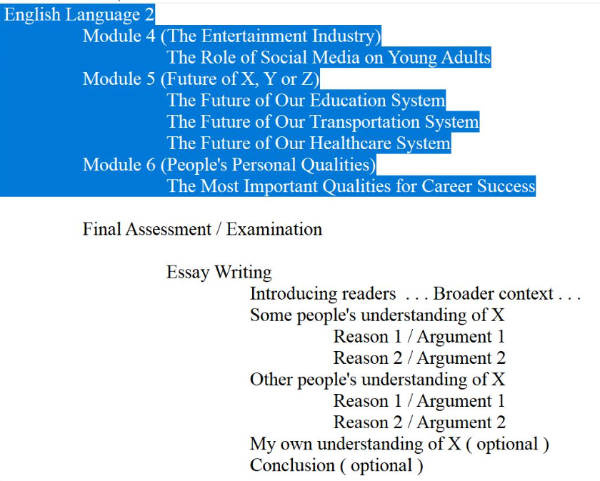
Kind regards,
Mr. Medic, D.Sc.

